CO-4 AT-2 - Coding Golf Competition

Name of the student : K.Nikhil
Reg No: 192525307
Date: 19/08/2026

Q1)
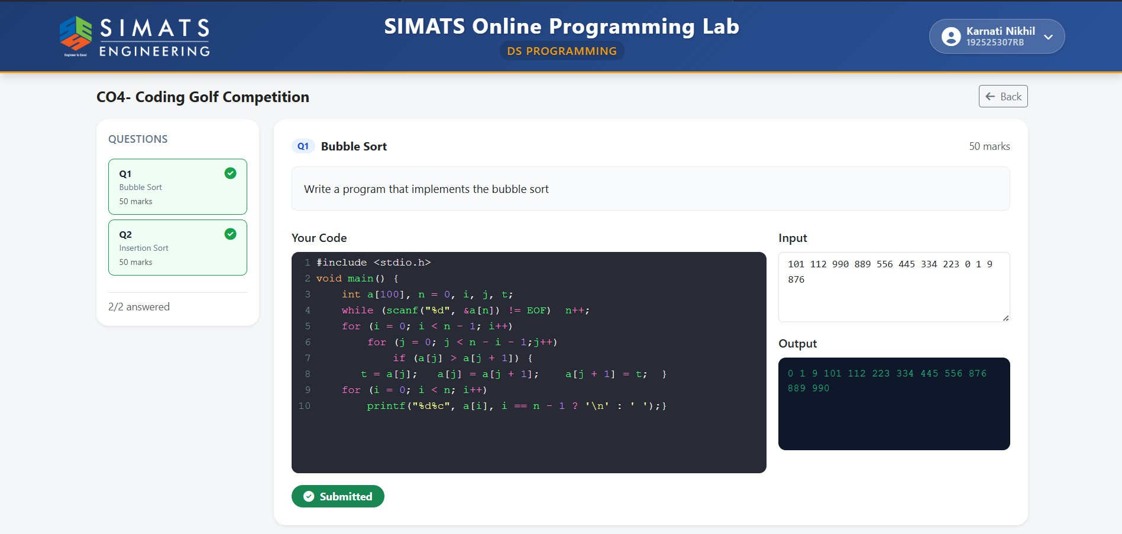

Q2)
